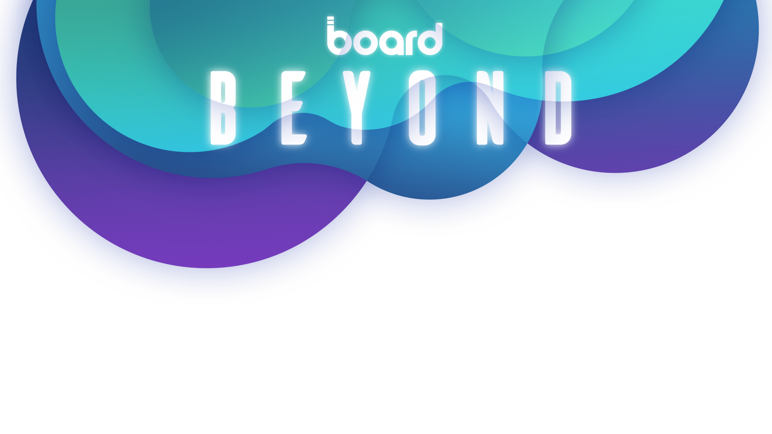

I’m writing to request approval to attend Board Beyond Americas, a free one-day event taking place on Wednesday, June 12th 2024 at the Langham Hotel in Boston. See details about the event here.

The conference, hosted by Board, is a fantastic chance for me to understand how to accelerate transformation within the business to increase value and productivity. I’m keen to learn more about the latest solutions in the market and why they present the incredible prospect of leaving spreadsheets and legacy processes behind and adopting a new, more intelligent way to plan.

In addition to inspirational keynotes, real-world case studies from global companies, and industry networking opportunities, the conference details how Intelligent Planning can help us planning for growth to reach our vision and targets.
And the best part of all of this? It is free to attend! I can’t imagine a more cost-effective way to learn about the latest technologies to enhance our operations. In short, this is a conference we cannot afford to miss, and with it, I’d like to focus on finding solutions and best practices that will benefit these projects:
• [add project or initiative]
• [add project or initiative]

Here’s an approximate breakdown of conference costs:

Airfare/Ground Transportation: | $ XX
Accommodation:  Registration Fee: | $ XX  $ FREE
Total: | $ XXX
I will share a post-conference summary with an action plan to help us optimize our investment in Board.

Thank you for considering this request.

Regards,

